1. Type ‘View Integration System’in command bar then select Submit Payroll Input (On-Cycle).

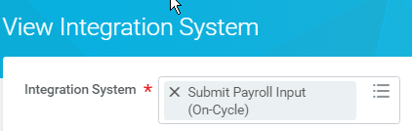

1. Click on the related action menu beside Submit Payroll Input (On-Cycle). Hover over Template Model and choose Generate Spreadsheet Template.

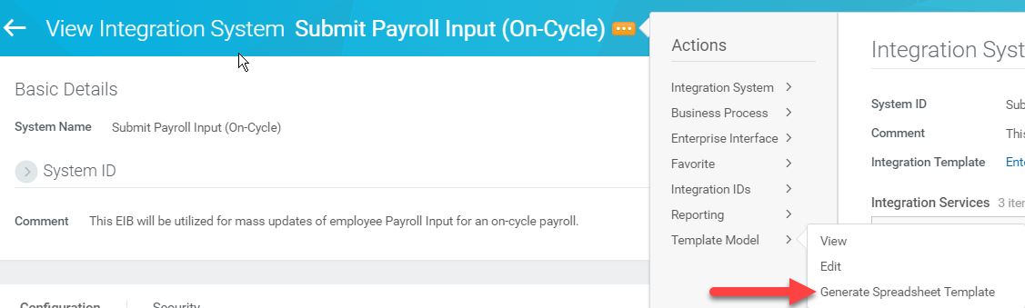

1. Click the box next to Generate Spreadsheet with Data, submit and done.

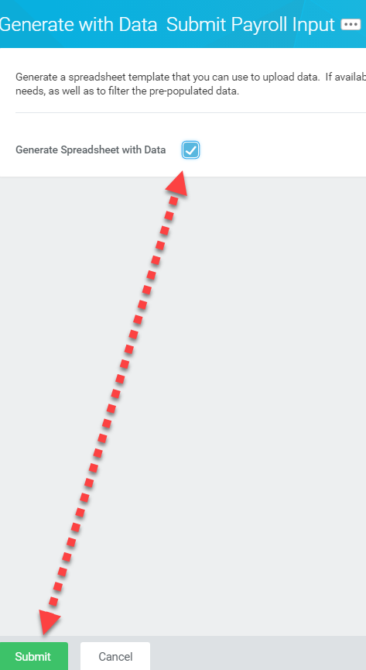

1. Once the EIB is ready you will get a notification in the rt hand corner that you can click on, or look in your notifications Inbox.

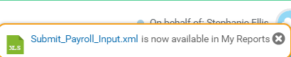

1. You can now open the EIB and enter the data. These are the only columns needed to run the EIB:

* Spreadsheet Key – see example below this just numbers each row with an identifying number.
* Row ID – This numbers each row - for instance when one employee has two lines. (Example: Scott has a Incentive amount and a Holiday amount, so you would type Row ID 1 on the Incentive and Row ID 2 on the Holiday). Otherwise each employee has 1 for a single entry.
* Batch Id – Make sure you have one created for what you are loading (see example below).
* Start Date – format the date as yyyy-mm-dd by right clicking cell, choosing Number tab, Custom and manually typing “yyyy-mm-dd” into the space as shown below.

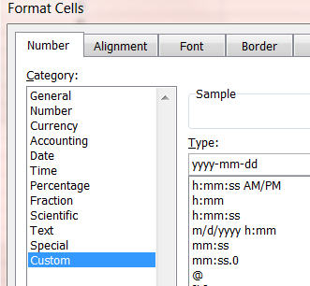

* End Date – same formatting - Important: start and end dates will be beginning and end of processing week for the particular Incentive amount you are loading).
* Worker – this will be Work Day’s Employee ID. Note: You will need to take the ID and format it as =Text(A1,”100000”) in order to load the file properly. Format them in a blank workbook and once formatted copy and paste the new formatted ID into the EIB.
* Earning – type View Earnings in WD and pull up the earnings code you need.

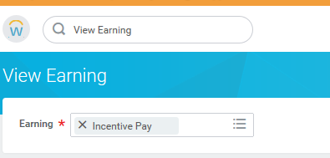

Once you hit ok, you will see the Code listed under Name of Earnings Code.

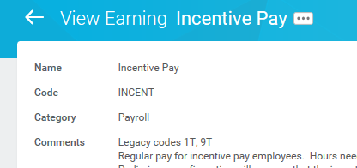

* Amount

Example of EIB shown below so you can see the items mentioned above.

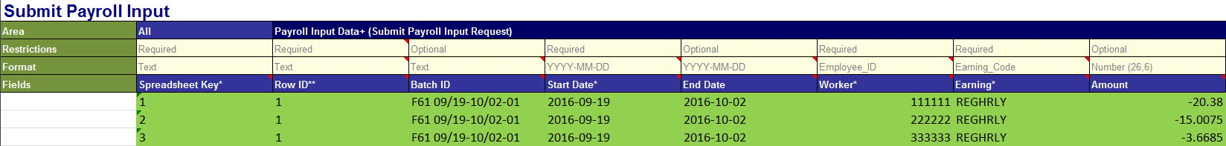

Once columns are filled out you need to save the EIB as XML Spreadsheet 2003 in your backup.

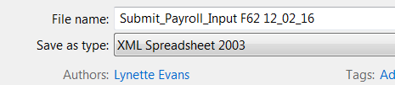

NOTE***Make sure to test the EIB data in Sandbox prior to loading in Production. This will allow you to test the data and confirm its loading what you want.

**Now you are ready to load your EIB.**

1. Type in Launch/Schedule Integration.

Select the EIB/Integration - Request One-Time Payment. Run Frequency will be Run Now.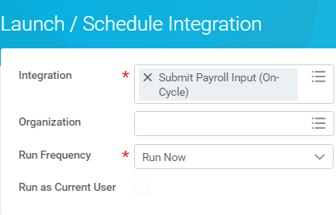

1. Then hit ok 
2. Attach the EIB you have edited and saved by clicking inside the Value box on the very first row and choosing Create Integration Attachment.

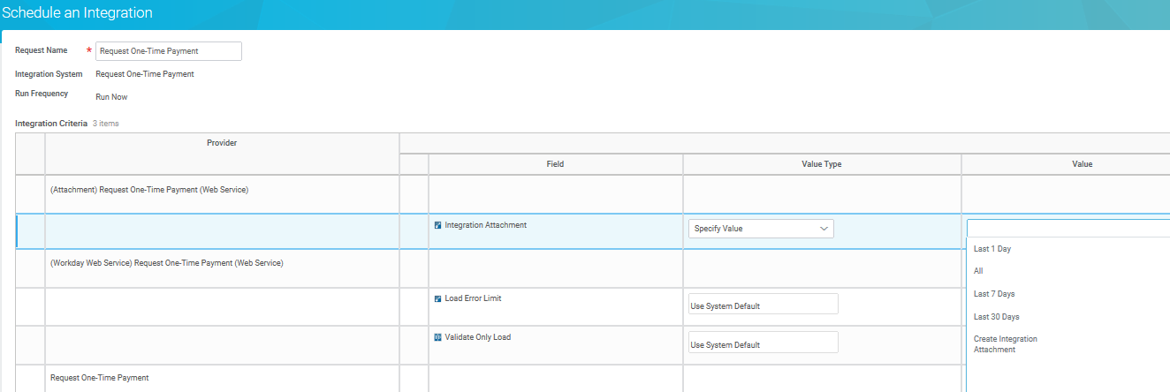

1. Click on attach  then once you attach your EIB hit ok 
2. Click the Value Type on the Validate Only Load row and choose “Specify Value” and then click on the blue box.  (This will validate your EIB before you load it and show you any errors in your data).

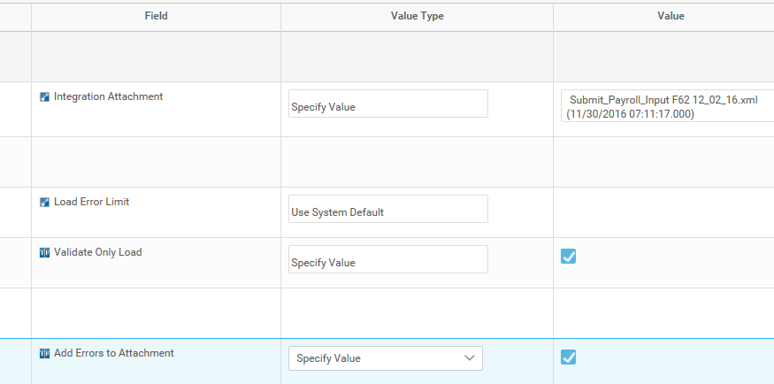

1. Click on Add Errors to Attachment box, as well. Click ok and Refresh until complete.

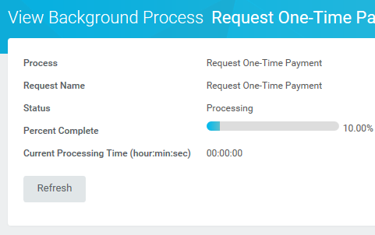

1. If you have errors click on the drop down by Number of Errors to view details

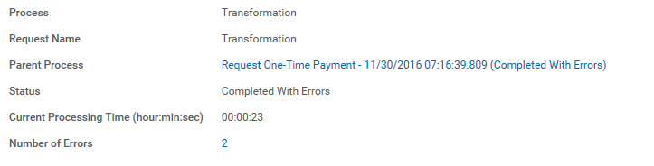

A box will pop up and allow you to view the errors.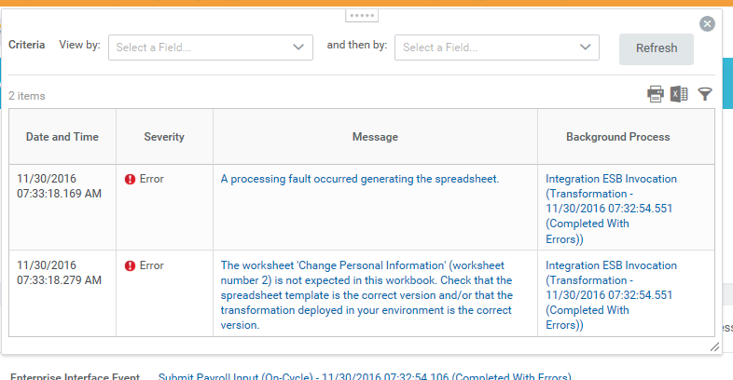

1. Repeat the same process you just did however DO NOT click on validate or Add errors and hit ok

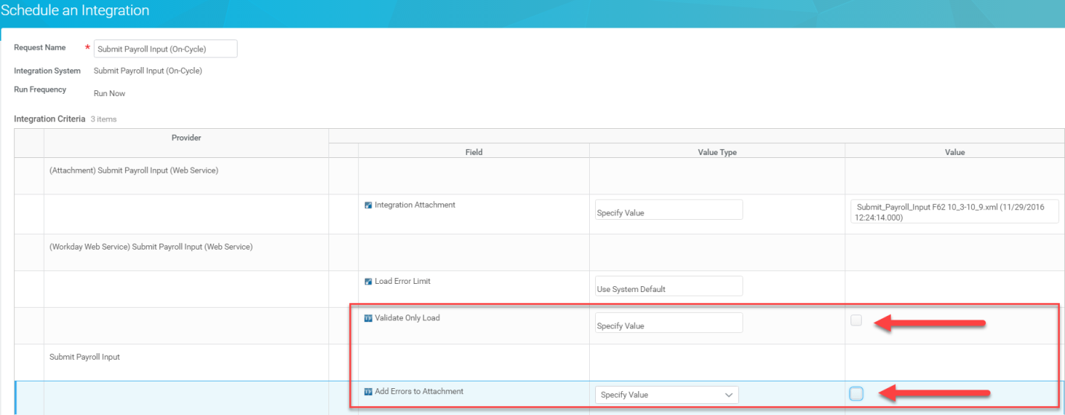

Once the status is showing Completed scroll down to Execution Summary to verify all the records processed. If there are errors, you will see them here.

